
AML PROJECT REPORT

BEGINWITH

https://github.com/arryansh5/BEGINWITH.git

Submitted to : Santosh Panda
Submitted by Arryansh Messon
590013268
B - 9

Title
BEGINWITH : Predicting stock trends and evaluating IPO performance

Abstract
BEGINWITH is a tool that project presents a full-stack financial analysis tool to help who beginner's in investing in making data-driven decisions. The system integrates a Machine Learning module for predicting next-day stock price movements using Logistic Regression and a Rule-Based module for evaluating Initial Public Offerings (IPOs)
Where Python is used to make the backend and React for the frontend
The application provides real-time trend scanning, historical tracking, and risk-adjusted predictions based on technical indicators like Moving Averages and Volume metrics.

Introduction
In modern financial world , To begin with investing is difficult because of it complexity to identify high-probability trades BEGINWITH aims to bridge that gap by automating technical analysis.
The BEGINWITH focuses on two key areas:
    - Stock Prediction: Using historical price data to predict short-term direction.
    - IPO Evaluation: Analyzing market sentiment (GMP) and demand (Subscription Rate) to grade new market entries.

Literature review
Traditional stock analysis usually relies on technical indicators like Moving Averages (MA) to understand market trends and decide when to buy or sell. These tools are helpful, but they often depend on how a person interprets the data. Two analysts looking at the same chart might reach different conclusions, which can lead to inconsistency or bias.
With the growth of Machine Learning, there’s a shift toward more data-driven methods. Models like Logistic Regression can look at several factors at the same time—such as price changes, trading volume, and momentum—and learn patterns from past data. Instead of relying on gut feeling or manual interpretation, the model evaluates everything in a more consistent and objective way.
By combining these traditional indicators with a machine learning approach, the system becomes more informative. Rather than just giving a simple “Buy” or “Sell” signal, it produces a “Confidence Score” that shows how strong the prediction is. This makes it easier to understand not just what the model suggests, but also how reliable that suggestion might be, helping users make more informed decisions.

Methodology
The application is designed using a modular three-tier architecture, which helps keep data processing separate from how users interact with the system.:
  - The data acquisition layer fetches around two years of live OHLCV market data using the yfinance API. This ensures that all machine learning predictions are based on the latest closing prices instead of relying on static or outdated datasets.
  - In the machine learning pipeline, the raw data is processed through feature engineering to calculate 5-day and 10-day moving averages along with volume momentum. These features are then normalized using StandardScaler, and a Logistic Regression model is trained on the fly for each specific stock ticker.
  - The predictive logic uses this model to generate binary outputs (UP or DOWN) along with a confidence score using predict_proba. This score is then categorized into Low, Medium, or High risk levels to make the results easier to understand.
  - The backend, built with FastAPI, acts as a bridge between the model and the frontend. It handles requests, runs the machine learning logic, and stores data in a history.json file so that user predictions can be tracked across sessions.
  - The frontend is developed using React, featuring a clean and minimal dashboard. It uses dynamic state management to show real-time updates, loading animations, and color-coded results for better clarity and user experience.

Market-Intelligence-Dashboard/
├── main.py # Backend Entry Point (FastAPI)
├── data.py # Machine Learning & Data Logic (yfinance)
├── history.json # Persistent Prediction History
├── .gitignore # Git ignore rules
└── frontend/ # React Application (Vite)
├── src/
│ ├── App.jsx # Main UI & State Logic
│ ├── App.css # Custom Minimalist Styling
│ ├── main.jsx # Frontend Entry Point
│ └── index.css # Global Global Base Styles
├── package.json # Frontend Dependencies
├── vite.config.js # Vite Configuration
└── index.html # HTML Shell

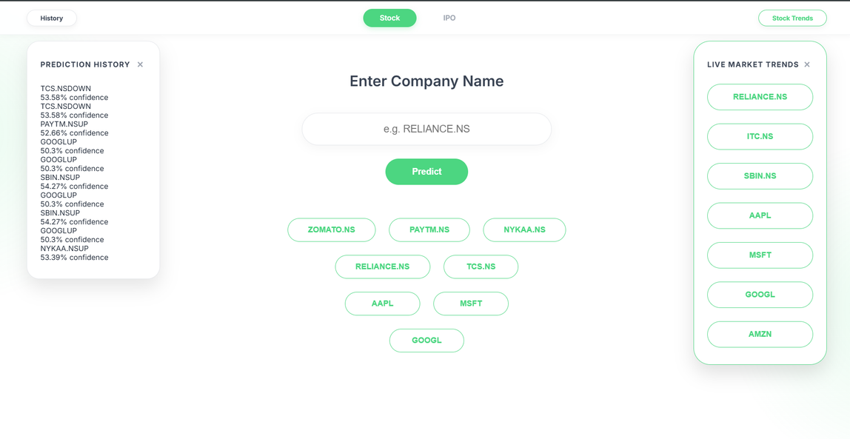

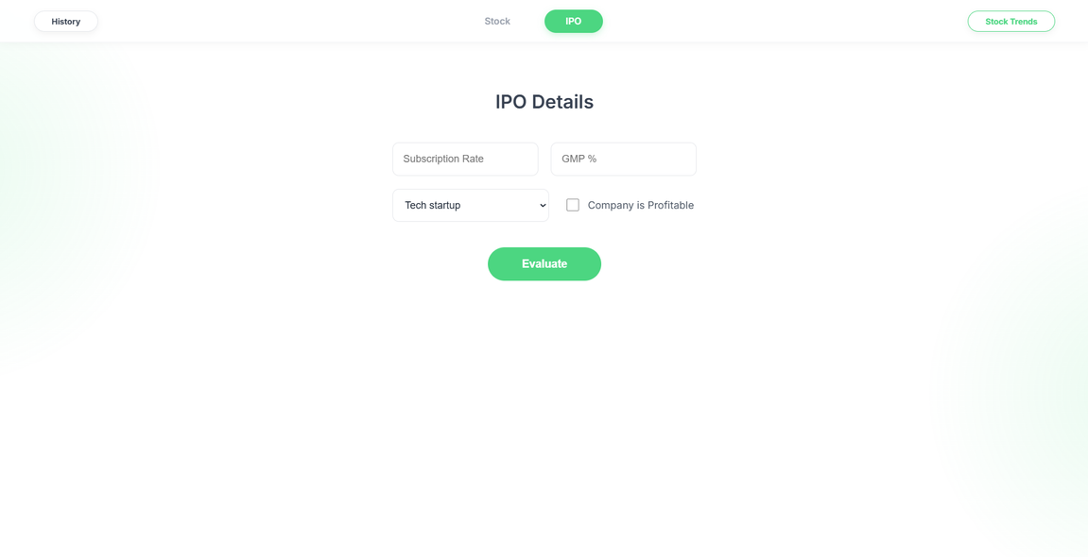

Experiment & Results
- The model was tested on a range of major indices, including both NSE and NYSE stocks.
- For confidence calculation, the model uses predict_proba to estimate how certain it is about a predicted trend. If the confidence level is above 65%, the prediction is labeled as “Low Risk.”
- For trend scanning, the system looks for situations where the short-term moving average (MA5) crosses above the medium-term moving average (MA10). This is a well-known “Golden Cross” signal, often associated with a potential upward trend.
- To keep track of performance, a JSON-based history system is used. This allows the application to store past predictions so users can review them later and check how consistent the model has been over time

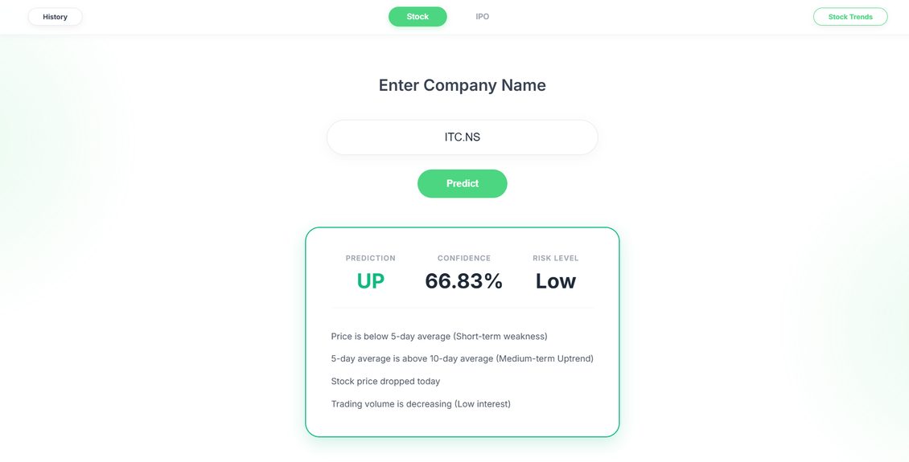
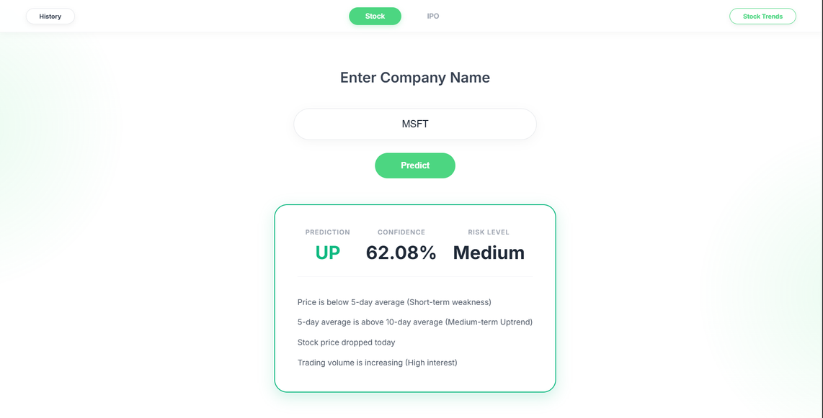

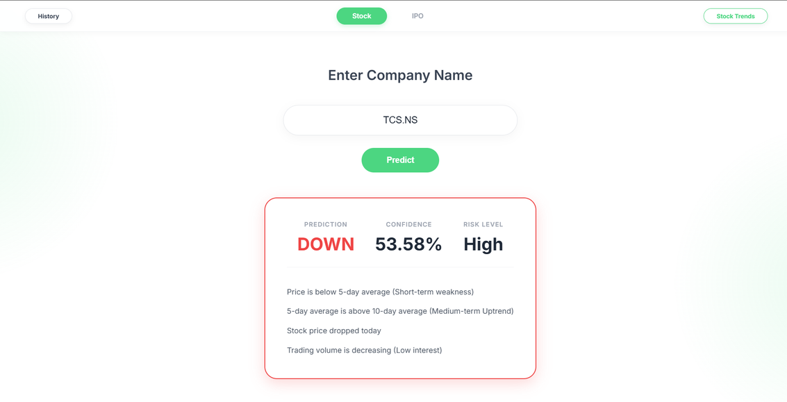

Conclusion & Future Work
BEGINWITH shows how combining Machine Learning with traditional technical indicators can create a more reliable and objective way to analyze the market. Instead of depending on subjective chart reading, the use of a Logistic Regression pipeline allows the system to generate predictions backed by data, along with clear confidence scores. The interface is designed to present these insights in a simple and readable way, making the information easier to understand and use.
Future Work
Advanced Neural Networks: Moving beyond linear models to LSTM (Long Short-Term Memory) networks would improve the system’s ability to handle time-series data. These models are better at capturing long-term patterns and dependencies that simpler models may miss.
Sentiment Analysis: Adding Natural Language Processing (NLP) can help the system analyze financial news, earnings reports, and social media discussions. This would allow it to factor in market sentiment and sudden events, not just technical indicators.
Real-Time Ecosystem: Introducing WebSockets for live price updates and alerts, along with building portfolio management features, would expand the system into a more complete platform. This would turn it from a prediction tool into a more practical, all-in-one solution for tracking and managing investments.

References:
- Yahoo Finance API (yfinance): Used for fetching real-time market data and historical OHLCV intervals.
Source: https://pypi.org/project/yfinance/
- Scikit-Learn Documentation: Referenced for understanding supervised learning algorithms, particularly LogisticRegression and StandardScaler for data normalization.
Source: https://scikit-learn.org/stable/
- FastAPI Framework: Used as a guide for building high-performance asynchronous APIs and handling features like Cross-Origin Resource Sharing (CORS).
Source: https://fastapi.tiangolo.com/
- Investopedia (Technical Analysis): Consulted for concepts like the “Golden Cross” and moving average crossovers (MA5 and MA10) as indicators of market trends.
Source: https://www.investopedia.com/terms/t/technicalanalysis.asp
- Chittorgarh (IPO Data Analysis): Referenced for insights on Grey Market Premium (GMP), subscription rates, and their relationship with IPO listing gains in the Indian market.
Source: https://www.chittorgarh.com/
- React.js Documentation: Used for best practices in state management and building component-based user interfaces for data-driven dashboards.
Source: https://react.dev/
- Groww Platform: Considered as a reference for clean, minimal fintech UI/UX design and improving accessibility for retail investors.
Source: https://groww.in/

